**To interface Push button with Arduino and write a program to turn ON LED, when push button is pressed.**

**Appratus**:Arduino Board***,*** Momentary button or Switch10K ohm resistor, hook-up wires***,*** Breadboard.

**Theory**:In a push-button with Arduino when we press that button the input voltage will change from high to low. then the pin connected to the push button gets to recognize and send to the Arduino that it gets some value on the input pins. now the code starts to process and the led connected to the Arduino will start to glow

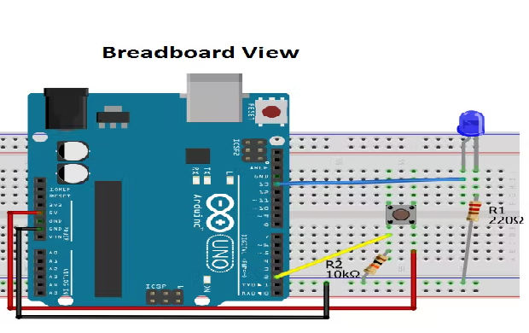

**Fig. 1: Interfacing of Push Button with Arduino on Simulator**

**Procedure:**

* Connected the LED to digital pin 13 of Arduino.
* The long leg of the LED (the positive leg, called the anode) to the other end of the resistor.
* Connect the short leg of the LED (the negative leg, called the cathode) to the GND.

**Code**:

int buttonPin = 2; // the number of pushbutton p

int ledPin = 13; // the number of LED pin

int buttonState = 0; // variable for reading the status of readings

void setup() {

pinMode(ledPin, OUTPUT);

pinMode(buttonPin, INPUT);

}

void loop() {

buttonState = digitalRead(buttonPin);

if (buttonState == HIGH) {

digitalWrite(ledPin, HIGH);

}

else {digitalWrite(ledPin, LOW);}

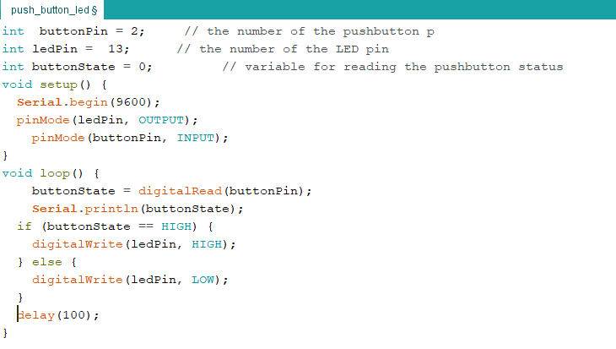

**Fig. 2:** Setting up code for Push Button with Arduino

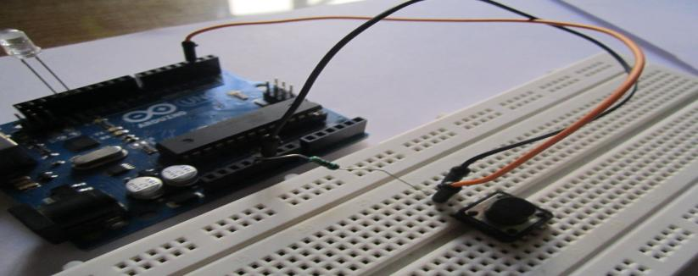

**Fig. 3:** Interfacing of Push Button with Arduino